Dear Woodward Families: November 24, 2023

2023/2024 Woodward Wildcats Wear Clothing Purchase
Orders Available On-line Until Monday December 11th

We are pleased to be able to offer Wildcats Wear Clothing items for purchasing at this time. Now is the chance for our students and interested family members who don’t yet own any Wildcats Wear to show their school spirit and wear our school colours and logo with pride. Families may purchase t-shirts, long-sleeved shirts, and hoodies at this time.

Pricing: T-shirts are offered at $14, long-sleeved shirts at $20 and hoodies at $33 (all taxes included).
Please note that this is not a fundraiser – all Woodward Wildcats clothing items are being offered at no extra cost to our families.

Design Features: Please see the visual below displaying the logo design and colours you may choose for the t-shirts, long-sleeved shirts, and hoodies. Colour choices are either Red or Sport Grey. The logo is red and black, as shown, and will be on the front of the clothing.

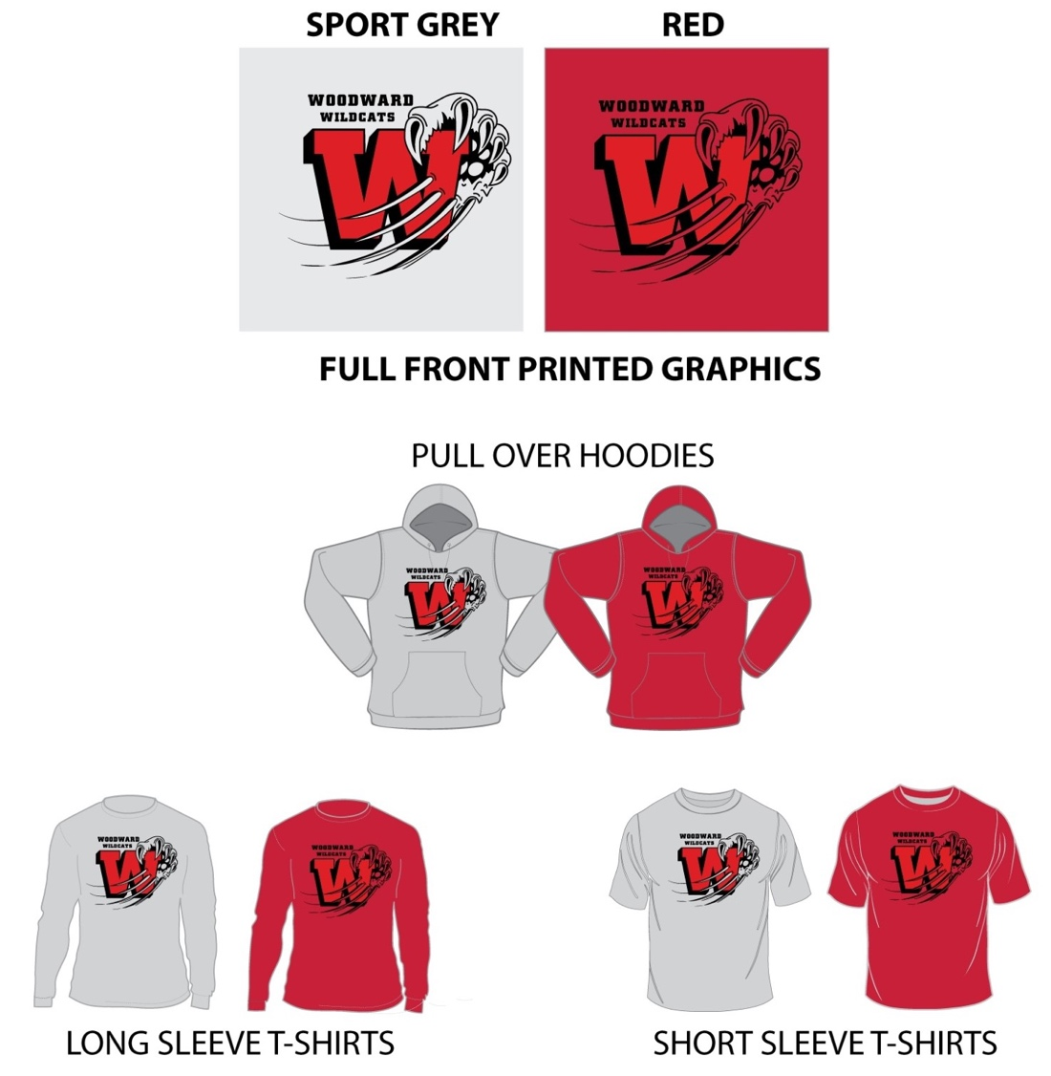
Youth sizes: XS (2-4), S (6-8), M (10-12), L (14-16), XL (18-20)

How To Order: Our Admin Assistant, Ms. Keung, has set up a clothing order on School Cash On-line, and families can now purchase Wildcats Wear t-shirts, long sleeved shirts, and hoodies. To avoid confusion about what was ordered and what payments were made, we will only be taking orders online in SchoolCashOnline. Please have your orders in by Monday, December 11, 2023.

Sizing: We highly recommend that you choose larger sizes for your child’s clothing choices. Larger sizes are more comfortable and allow room for your child to grow. If you are not sure of your child’s size, clothing samples are now available for sizing at the front office for parents who would like to have their child try on the clothing items – from 8:30 – 8:45 and 2:45 – 3:15 pm daily until December 8th.

Deliver Will Be Likely Be In Late January: We hope to be able to send all of the purchase orders we receive to the vendor during the week of December 11th to 15th – thus we expect that these clothing items will be delivered to our students in late January.

